System Design Document

Mirror

Version : 1.1
Date : 03-11-2015
Project : Mirror
Author : Usha Devi .K

Document Revisions

Date | Version | Description | Author | Approved By
30-10-2015 | 1.0 | Mirror – SDD | Usha Devi .K | Dhanalakshmi SB
03-11-2015 | 1.1 | Mirror – SDD | Usha Devi .K | Dhanalakshmi SB

Index
1 Overview 4
2 Development Tools 4
3 System Process 5
3.1 Scope of the Project 5
4 System Design 5
4.1 Architecture Diagram 5
4.2 Data flow Diagram 6
5 Database Design 8
5.1 Schema Definition 8
5.2 Schema Diagram 18

Overview
The project Mirror was designed and hosted for Aparajitha Corporate Services Private Limited. This web application is designed to manage the following modules. The indent of this project is to manage the below mentioned modules effectively, efficiently and improve the overall performance in order to moving forward the next level.
- Administrator Module
- Knowledge Team Module
- Techno Functional Team Module
- Client Module
- Service Provider Module
Proposed system of the Web application is the some of features, which are listed and explained below. Proposed system will be categorized by the seven kind of users. That user's are,
      - Admin
      - Knowledge Team Manager
      - Knowledge Team User
      - Techno Functional Team User
      - Client Admin
      - Client User
      - Service Provider

Development Tools
The following Technologies are to be used for developing Web Application for Mirror:
      - Python 2.7
      - Tornado Framework
      - Jquery
      - HTML
      - CSS
      - MySQL

System Process

Scope of the Project
The project was designed for Aparajitha Corporate Services Private Limited. From here on the database will be the storage of all the important data. This will provide the effective security to the system more over the ultimate user can be able to get back with any kind of highly usable reports which he/she would like to see. The system will help to input the specified data in a sequential manner.

System Design

Architecture Diagram
Access to this web system is possible using browsers with internet connection. For Android Mobile App/Tablet App, iPhone/iPad App, Blackberry 10 App, accessing will be made through the Apps for the respective platforms with internet connection.

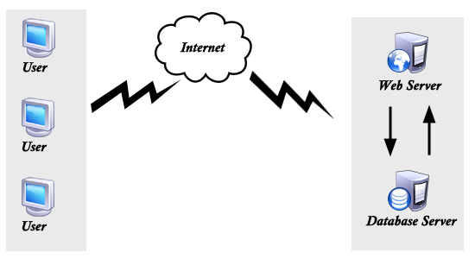

Data flow Diagram

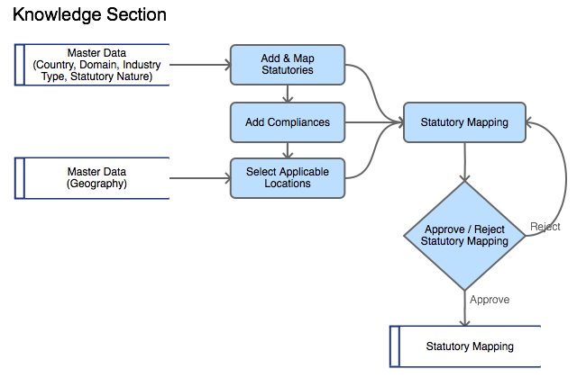

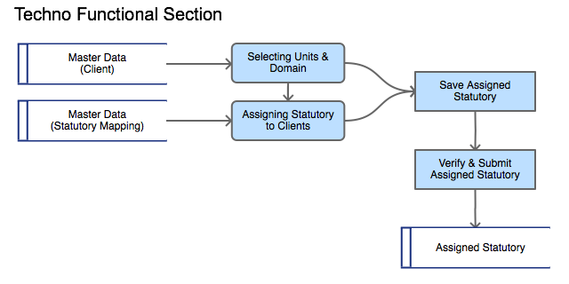

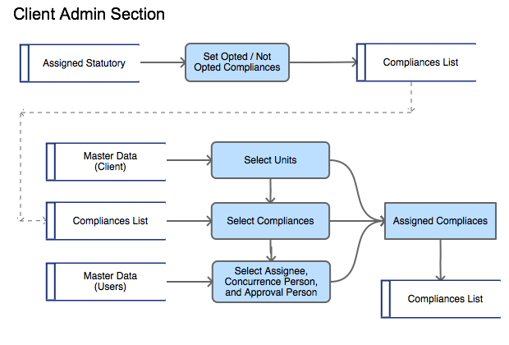

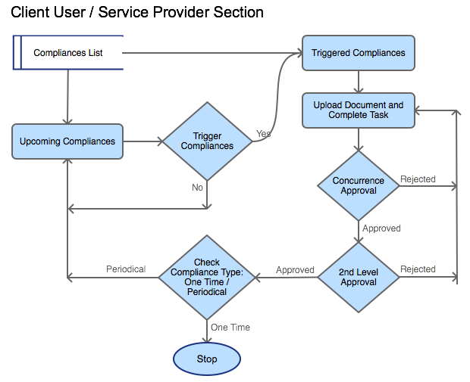

Database Design

Schema Definition
# | Table Name | Fields | Data type | Size | Default Value | Key | Reference
Forms
1 | tbl_forms | form_id | INT |  |  | PK
1 | tbl_forms | form_name | VARCHAR | 50
1 | tbl_forms | form_url | VARCHAR | 50
1 | tbl_forms | form_order | VARCHAR | 50
1 | tbl_forms | form_type | INT |  |  |  | (INT: 0 - it,  1 - knowledge,  2 - techno,  3 - client,  4 - serviceprovider)
1 | tbl_forms | category | INT |  |  |  | (INT: 0 - Masters,  1 - Transactions,  2 - Reports,  3 - Settings)
1 | tbl_forms | admin_form | TINYINT
1 | tbl_forms | parent_menu | VARCHAR | 50
User Groups
2 | tbl_user_groups | user_group_id | INT |  |  | PK
2 | tbl_user_groups | user_group_name | VARCHAR | 50
2 | tbl_user_groups | form_type | INT |  |  |  | (INT: 0 - it,  1 - knowledge,  2 - techno,  3 - client,  4 - serviceprovider)
2 | tbl_user_groups | form_ids | VARCHAR | 250 |  |  | Multiple form_ids concatenated with “,”
2 | tbl_user_groups | is_active | TINYINT |  | 1
2 | tbl_user_groups | updated_by | INT
2 | tbl_user_groups | updated_on | TIMESTAMP |  | CURRENT_TIMESTAMP
Client User Groups
3 | tbl_client_user_groups | client_id | INT |  |  | FK | tbl_client_groups
3 | tbl_client_user_groups | user_group_id | INT |  |  | PK
3 | tbl_client_user_groups | user_group_name | VARCHAR | 50
3 | tbl_client_user_groups | form_type | INT |  |  |  | (INT: 0 - it, 1 - knowledge,  2 - techno,  3 - client,  4 - serviceprovider)
3 | tbl_client_user_groups | form_ids | LONGTEXT |  |  |  | Multiple form_ids  concatenated with “,”
3 | tbl_client_user_groups | is_active | TINYINT |  | 1
3 | tbl_client_user_groups | updated_by | INT
3 | tbl_client_user_groups | updated_on | TIMESTAMP |  | CURRENT_TIMESTAMP

Users
4 | tbl_users | user_id | INT |  |  | PK
4 | tbl_users | username | VARCHAR | 100
4 | tbl_users | password | VARCHAR | 50
4 | tbl_users | user_details_id | INT
4 | tbl_users | client_id | INT
4 | tbl_users | is_active | TINYINT |  | 1
4 | tbl_users | updated_by | INT
4 | tbl_users | updated_on | TIMESTAMP |  | CURRENT_TIMESTAMP
User Sessions
5 | tbl_user_sessions | session_id | INT |  |  | PK
5 | tbl_user_sessions | user_id | INT |  |  | FK | tbl_users
5 | tbl_user_sessions | login_time | TIMESTAMP
User Details
6 | tbl_user_details | user_details_id | INT |  |  | PK
6 | tbl_user_details | email_id | VARCHAR | 100
6 | tbl_user_details | user_group_id | INT |  |  | FK | tbl_user_groups
6 | tbl_user_details | form_type | INT |  |  |  | (INT: 0 - it,  1 - knowledge,  2 - techno,  3 - client,  4 - serviceprovider)
6 | tbl_user_details | employee_name | VARCHAR | 50
6 | tbl_user_details | employee_code | VARCHAR | 50
6 | tbl_user_details | contact_no | INT
6 | tbl_user_details | address | VARCHAR | 250
6 | tbl_user_details | designation | VARCHAR | 50
6 | tbl_user_details | domain_id | INT |  |  | FK | tbl_domains
6 | tbl_user_details | updated_by | INT
6 | tbl_user_details | updated_on | TIMESTAMP |  | CURRENT_TIMESTAMP
Client User Details
7 | tbl_client_user_details | client_id | INT |  |  | FK | tbl_client_groups
7 | tbl_client_user_details | user_details_id | INT |  |  | PK
7 | tbl_client_user_details | email_id | VARCHAR | 100
7 | tbl_client_user_details | user_group_id | INT |  |  | FK | tbl_client_user_groups
7 | tbl_client_user_details | employee_name | VARCHAR | 50
7 | tbl_client_user_details | employee_code | VARCHAR | 50 |  |  | Optional for service providers
7 | tbl_client_user_details | contact_no | INT
7 | tbl_client_user_details | seating_unit_id | INT |  |  | FK | tbl_units (Optional for service providers)
7 | tbl_client_user_details | user_level | INT
7 | tbl_client_user_details | country_ids | VARCHAR | 250 |  |  | Multiple country_ids  concatenated with “,”
7 | tbl_client_user_details | domain_ids | VARCHAR | 250 |  |  | Multiple domain_ids  concatenated with “,”
7 | tbl_client_user_details | unit_ids | LONGTEXT |  |  | FK | Multiple units_ids  concatenated with “,”
7 | tbl_client_user_details | is_admin | TINYINT |  | 0
7 | tbl_client_user_details | is_service_provider | TINYINT |  | 0
7 | tbl_client_user_details | service_provider_id | INT |  |  | FK | tbl_service_provider
7 | tbl_client_user_details | updated_by | INT
7 | tbl_client_user_details | updated_on | TIMESTAMP |  | CURRENT_TIMESTAMP
Countries
8 | tbl_countries | country_id | INT |  |  | PK
8 | tbl_countries | country_name | VARCHAR | 50
8 | tbl_countries | is_active | TINYINT |  | 1
8 | tbl_countries | updated_by | INT
8 | tbl_countries | updated_on | TIMESTAMP |  | CURRENT_TIMESTAMP
Domains
9 | tbl_domains | domain_id | INT |  |  | PK
9 | tbl_domains | domain_name | VARCHAR | 50
9 | tbl_domains | is_active | TINYINT |  | 1
9 | tbl_domains | updated_by | INT
9 | tbl_domains | updated_on | TIMESTAMP |  | CURRENT_TIMESTAMP
Industries
10 | tbl_industries | industry_id | INT |  |  | PK
10 | tbl_industries | industry_name | VARCHAR | 50
10 | tbl_industries | is_active | TINYINT |  | 1
10 | tbl_industries | updated_by | INT
10 | tbl_industries | updated_on | TIMESTAMP |  | CURRENT_TIMESTAMP
Statutory Natures
11 | tbl_statutory_natures | statutory_nature_id | INT |  |  | PK
11 | tbl_statutory_natures | statutory_nature_name | VARCHAR | 50
11 | tbl_statutory_natures | is_active | TINYINT |  | 1
11 | tbl_statutory_natures | updated_by | INT
11 | tbl_statutory_natures | updated_on | TIMESTAMP |  | CURRENT_TIMESTAMP
Geography Levels
12 | tbl_geography_levels | level_id | INT |  |  | PK
12 | tbl_geography_levels | level_position | INT
12 | tbl_geography_levels | level_name | VARCHAR | 50
12 | tbl_geography_levels | country_id | INT |  |  | FK | tbl_countries
12 | tbl_geography_levels | is_active | TINYINT |  | 1
12 | tbl_geography_levels | updated_by | INT
12 | tbl_geography_levels | updated_on | TIMESTAMP |  | CURRENT_TIMESTAMP
Geographies
13 | tbl_geographies | geography_id | INT |  |  | PK
13 | tbl_geographies | geography_name | VARCHAR | 50
13 | tbl_geographies | level_id | INT |  |  | FK | tbl_geography_levels
13 | tbl_geographies | parent_ids | VARCHAR | 50 |  |  | Multiple geography_ids  concatenated with ","
13 | tbl_geographies | is_active | TINYINT |  | 1
13 | tbl_geographies | updated_by | INT
13 | tbl_geographies | updated_on | TIMESTAMP |  | CURRENT_TIMESTAMP
Statutory Levels
14 | tbl_statutory_levels | level_id | INT |  |  | PK
14 | tbl_statutory_levels | level_position | INT
14 | tbl_statutory_levels | level_name | VARCHAR | 50
14 | tbl_statutory_levels | country_id | INT |  |  | FK | tbl_countries
14 | tbl_statutory_levels | is_active | TINYINT |  | 1
14 | tbl_statutory_levels | updated_by | INT
14 | tbl_statutory_levels | updated_on | TIMESTAMP |  | CURRENT_TIMESTAMP
Statutories
15 | tbl_statutories | statutory_id | INT |  |  | PK
15 | tbl_statutories | statutory_name | VARCHAR | 50
15 | tbl_statutories | level_id | INT |  |  | FK | tbl_statutory_levels
15 | tbl_statutories | parent_ids | VARCHAR | 50 |  |  | Multiple statutory_ids  concatinated with ","
15 | tbl_statutories | is_active | TINYINT |  | 1
15 | tbl_statutories | mapping_id | INT |  |  | FK | tbl_statutory_mappings
15 | tbl_statutories | updated_by | INT
15 | tbl_statutories | updated_on | TIMESTAMP |  | CURRENT_TIMESTAMP
Compliances
16 | tbl_compliances | compliance_id | INT
16 | tbl_compliances | compliance_task | VARCHAR | 100
16 | tbl_compliances | description | LONGTEXT
16 | tbl_compliances | document | VARCHAR | 100
16 | tbl_compliances | format | VARCHAR | 100
16 | tbl_compliances | penal_consequences | LONGTEXT
16 | tbl_compliances | frequency | VARCHAR | 100
16 | tbl_compliances | statutory_dates | LONGTEXT |  |  |  | json-string: list of  dictionaries with keys  statutory_date, statutory_month, trigger_before_days
16 | tbl_compliances | repeats_type | VARCHAR | 100
16 | tbl_compliances | repeats_every | VARCHAR | 100
16 | tbl_compliances | duration | TINYINT |  | 1
16 | tbl_compliances | duration_type | VARCHAR | 50
16 | tbl_compliances | mapping_id | INT |  |  | FK | tbl_statutory_mappings
16 | tbl_compliances | is_active | TINYINT |  | 1
16 | tbl_compliances | updated_by | INT
16 | tbl_compliances | updated_on | TIMESTAMP |  | CURRENT_TIMESTAMP
Statutory Mappings
17 | tbl_statutory_mappings | mapping_id | INT |  |  | PK
17 | tbl_statutory_mappings | country_id | INT |  |  | FK | tbl_countries
17 | tbl_statutory_mappings | domain_id | INT |  |  | FK | tbl_domains
17 | tbl_statutory_mappings | industry_id | INT |  |  | FK | tbl_industries
17 | tbl_statutory_mappings | statutory_nature_id | INT |  |  | FK | tbl_statutory_natures
17 | tbl_statutory_mappings | status | TINYINT |  | 0
17 | tbl_statutory_mappings | is_active | TINYINT |  | 1
17 | tbl_statutory_mappings | updated_by | INT
17 | tbl_statutory_mappings | updated_on | TIMESTAMP |  | CURRENT_TIMESTAMP
Statutory Mappings – Applicable Location
18 | tbl_statutory_geographies | mapping_id | INT
18 | tbl_statutory_geographies | geography_id | INT |  |  | FK | tbl_geographies
Client Groups
19 | tbl_client_groups | client_id | INT
19 | tbl_client_groups | group_name | VARCHAR | 50
19 | tbl_client_groups | domain_ids | VARCHAR | 200 |  |  | Multiple domain_id  concatenated with “,”
19 | tbl_client_groups | logo | VARCHAR | 200
19 | tbl_client_groups | contract_from | DATE
19 | tbl_client_groups | contract_to | DATE
19 | tbl_client_groups | no_of_user_licence | INT
19 | tbl_client_groups | total_disk_space | INT
19 | tbl_client_groups | sms_notification | TINYINT |  | 0
19 | tbl_client_groups | is_active | TINYINT |  | 1
19 | tbl_client_groups | updated_by | INT
19 | tbl_client_groups | updated_on | TIMESTAMP
Business Groups
20 | tbl_business_groups | business_group_id | INT |  |  | PK
20 | tbl_business_groups | business_group_name | VARCHAR | 100
20 | tbl_business_groups | client_id | INT |  |  | FK | tbl_client_groups
20 | tbl_business_groups | updated_by | INT
20 | tbl_business_groups | updated_on | TIMESTAMP

Legal Entities
21 | tbl_legal_entities |  |  | legal_entity_id | INT |  |  |  |  | PK
21 |  |  |  | legal_entity_name | VARCHAR |  | 100
21 |  |  |  | business_group_id | INT |  |  |  |  | FK |  | tbl_business_groups
21 |  |  |  | client_id | INT |  |  |  |  | FK |  | tbl_client_groups
21 |  |  |  | updated_by | INT
21 |  |  |  | updated_on | TIMESTAMP |  |  | CURRENT_TIMESTAMP
Divisions
22 | tbl_divisions |  |  | division_id | INT |  |  |  |  | PK
22 |  |  |  | division_name | VARCHAR |  | 100
22 |  |  |  | legal_entity_id | INT |  |  |  |  | FK |  | tbl_legal_entities
22 |  |  |  | business_group_id | INT |  |  |  |  | FK |  | tbl_business_groups
22 |  |  |  | client_id | INT |  |  |  |  | FK |  | tbl_client_groups
22 |  |  |  | updated_by | INT
22 |  |  |  | updated_on | TIMESTAMP |  |  | CURRENT_TIMESTAMP
Units
23 | tbl_units |  |  | unit_id | INT |  |  |  |  | PK
23 |  |  |  | division_id | INT |  |  |  |  | FK |  | tbl_divisions
23 |  |  |  | legal_entity_id | INT |  |  |  |  | FK |  | tbl_legal_entities
23 |  |  |  | business_group_id | INT |  |  |  |  | FK |  | tbl_business_groups
23 |  |  |  | client_id | INT |  |  |  |  | FK |  | tbl_client_groups
23 |  |  |  | country_id | INT |  |  |  |  | FK |  | tbl_countries
23 |  |  |  | geography_id | INT |  |  |  |  | FK |  | tbl_geographies
23 |  |  |  | unit_code | VARCHAR |  | 50
23 |  |  |  | unit_name | VARCHAR |  | 50
23 |  |  |  | industry_id | INT |  |  |  |  | FK |  | tbl_industries
23 |  |  |  | address | VARCHAR |  | 250
23 |  |  |  | postal_code | INT
23 |  |  |  | domain_ids | VARCHAR |  | 100 |  |  |  |  | Multiple domain_id  concatenated with “,”
23 |  |  |  | is_active | TINYINT |  |  | 1
23 |  |  |  | updated_by | INT
23 |  |  |  | updated_on | TIMESTAMP |  |  | CURRENT_TIMESTAMP
Client Configurations
24 | tbl_client_configurations |  |  | client_id | INT |  |  |  |  | FK |  | tbl_client_groups
24 |  |  |  | country_id | INT |  |  |  |  | FK |  | tbl_countries
24 |  |  |  | domain_id | INT |  |  |  |  | FK |  | tbl_domains
24 |  |  |  | period_from | VARCHAR |  | 50
24 |  |  |  | period_to | VARCHAR |  | 50
24 |  |  |  | updated_by | INT
24 |  |  |  | updated_on | TIMESTAMP
Client Settings
25 | tbl_client_settings |  |  | client_id | INT |  |  |  |  | FK |  | tbl_client_groups
25 |  |  |  | two_levels_of_approval | TINYINT
25 |  |  |  | assignee_reminder | INT
25 |  |  |  | escalation_reminder_In_advance | INT
25 |  |  |  | escalation_reminder | INT
Service Provider
26 |  | tbl_service_provider | servicer_provider_id |  | INT |  |  |  | PK
 |  | tbl_service_provider | service_provider_name |  | VARCHAR | 50
 |  | tbl_service_provider | address |  | VARCHAR | 500
 |  | tbl_service_provider | contract_from |  | DATE
 |  | tbl_service_provider | contract_to |  | DATE
 |  | tbl_service_provider | contact_person |  | VARCHAR | 50
 |  | tbl_service_provider | contact_no |  | INT
 |  | tbl_service_provider | client_id |  | INT |  |  |  | FK |  | tbl_client_groups
 |  | tbl_service_provider | updated_on |  | TIMESTAMP |  |  | CURRENT_TIMESTAMP
Client Saved Statutories
27 | tbl_client_saved_statutories |  |  | client_id | INT |  |  |  |  | FK |  | tbl_client_groups
27 |  |  |  | client_saved_statutory_id | INT |  |  |  |  | PK
27 |  |  |  | country_id | INT |  |  |  |  | FK |  | tbl_countries
27 |  |  |  | domain_id | INT |  |  |  |  | FK |  | tbl_domains
27 |  |  |  | unit_ids | VARCHAR |  | 250 |  |  |  |  | Multiple unit_ids  Concatinated with ","
27 |  |  |  | client_compliance_id | INT |  |  |  |  | PK
27 |  |  |  | updated_by | INT
27 |  |  |  | geography_id | INT |  |  |  |  | FK |  | Tbl_geographies
27 |  |  |  | updated_on | TIMESTAMP |  |  | CURRENT_TIMESTAMP
Client Statutories
28 | tbl_client_statutories |  |  | client_id | INT |  |  |  |  | FK |  | tbl_client_groups
28 |  |  |  | assign_statutory_id | INT |  |  |  |  | PK
28 |  |  |  | country_id | INT |  |  |  |  | FK |  | tbl_countries
28 |  |  |  | domain_id | INT |  |  |  |  | FK |  | tbl_domains
28 |  |  |  | unit_id | INT |  |  |  |  | FK |  | tbl_units
28 |  |  |  | client_compliance_id | INT |  |  |  |  | PK
28 |  |  |  | updated_by | INT
28 |  |  |  | geography_id | INT |  |  |  |  | FK |  | tbl_geographies
28 |  |  |  | updated_on | TIMESTAMP |  |  | CURRENT_TIMESTAMP

Client Compliances
29 | tbl_client_compliances | client_compliance_id | INT |  |  | FK | tbl_client_statutories
29 | tbl_client_compliances | statutory_id | INT |  |  | FK | (only ACT - 1st level)  Statutories
29 | tbl_client_compliances | applicable | TINYINT
29 | tbl_client_compliances | not_applicable_remarks | VARCHAR | 250
29 | tbl_client_compliances | compliance_id | INT
29 | tbl_client_compliances | compliance_applicable | TINYINT
29 | tbl_client_compliances | compliance_opted | TINYINT
29 | tbl_client_compliances | compliance_remarks | VARCHAR | 250
29 | tbl_client_compliances | updated_by | INT
29 | tbl_client_compliances | updated_on | TIMESTAMP |  | CURRENT_TIMESTAMP
Assigned Compliances
30 | tbl_assigned_compliances | client_id | INT |  |  | FK | tbl_client_groups
30 | tbl_assigned_compliances | country_id | INT |  |  | FK | tbl_countries
30 | tbl_assigned_compliances | unit_id | INT |  |  | FK | tbl_units
30 | tbl_assigned_compliances | compliance_id | INT |  |  | FK | tbl_compliances
30 | tbl_assigned_compliances | trigger_before_days | LONGTEXT |  |  |  | json-string: list of  Dictionaries with keys  date, day
30 | tbl_assigned_compliances | due_date | DATE
30 | tbl_assigned_compliances | validity_date | DATE
30 | tbl_assigned_compliances | assignee | INT |  |  | FK | tbl_client_users
30 | tbl_assigned_compliances | concurrence_person | INT |  |  | FK | tbl_client_users
30 | tbl_assigned_compliances | approval_person | INT |  |  | FK | tbl_client_users
30 | tbl_assigned_compliances | reassigned | TINYINT |  | 0
30 | tbl_assigned_compliances | is_active | TINYINT |  | 1
30 | tbl_assigned_compliances | updated_by | INT
30 | tbl_assigned_compliances | updated_on | TIMESTAMP |  | CURRENT_TIMESTAMP
Reassigned Compliances History
31 | tbl_reassigned_  Compliances_history | unit_id | INT |  |  | FK | tbl_units
31 | tbl_reassigned_  Compliances_history | compliance_id | INT |  |  | FK | tbl_compliances
31 | tbl_reassigned_  Compliances_history | assignee | INT |  |  | FK | tbl_client_users
31 | tbl_reassigned_  Compliances_history | reassigned_from | INT |  |  | FK | tbl_client_users
31 | tbl_reassigned_  Compliances_history | reassigned_date | DATE
31 | tbl_reassigned_  Compliances_history | remarks | VARCHAR | 500
31 | tbl_reassigned_  Compliances_history | updated_by | INT
31 | tbl_reassigned_  Compliances_history | updated_on | TIMESTAMP |  | CURRENT_TIMESTAMP

Compliance history
32 | tbl_compliance_history | compliance_history_id | INT |  |  | PK
32 | tbl_compliance_history | unit_id | INT |  |  | FK | tbl_units
32 | tbl_compliance_history | client_id | INT |  |  | FK | tbl_client_groups
32 | tbl_compliance_history | compliance_id | INT |  |  | FK | tbl_compliances
32 | tbl_compliance_history | start_date | DATE
32 | tbl_compliance_history | due_date | DATE
32 | tbl_compliance_history | completion_date | DATE
32 | tbl_compliance_history | documents | LONGTEXT
32 | tbl_compliance_history | validity_date | DATE
32 | tbl_compliance_history | next_due_date | DATE
32 | tbl_compliance_history | remarks | VARCHAR | 500
32 | tbl_compliance_history | completed_by | INT |  |  | FK | tbl_users
32 | tbl_compliance_history | completed_on | DATE
32 | tbl_compliance_history | concurrence_status | TINYINT
32 | tbl_compliance_history | concurred_by | INT
32 | tbl_compliance_history | concurred_on | DATE
32 | tbl_compliance_history | approve_status | TINYINT
32 | tbl_compliance_history | approved_by | INT
32 | tbl_compliance_history | approved_on | DATE
32 | tbl_compliance_history | updated_on | TIMESTAMP
Compliance Activity Log
33 | tbl_compliance_activity_log | compliance_activity_id | INT
33 | tbl_compliance_activity_log | unit_id | INT |  |  | FK | tbl_units
33 | tbl_compliance_activity_log | client_id | INT |  |  | FK | tbl_client_groups
33 | tbl_compliance_activity_log | compliance_id | INT |  |  | FK | tbl_compliance
33 | tbl_compliance_activity_log | activity_date | DATE
33 | tbl_compliance_activity_log | activity_status | DATE
33 | tbl_compliance_activity_log | compliance_status | TINYINT
33 | tbl_compliance_activity_log | remarks | LONGTEXT
Statutory Notifications Log
34 | tbl_statutory_notifications  _log | client_id | INT |  |  | FK | tbl_client_groups
34 | tbl_statutory_notifications  _log | country_id | INT |  |  | FK | tbl_countries
34 | tbl_statutory_notifications  _log | domain_id | INT |  |  | FK | tbl_domains
34 | tbl_statutory_notifications  _log | business_group_id | INT |  |  | FK | tbl_business_groups
34 | tbl_statutory_notifications  _log | legal_entity_id | INT |  |  | FK | tbl_legal_entities
34 | tbl_statutory_notifications  _log | division_id | INT |  |  | FK | tbl_divisions
34 | tbl_statutory_notifications  _log | unit_id | INT |  |  | FK | tbl_units
34 | tbl_statutory_notifications  _log | statutory_id | INT |  |  | FK | tbl_statutories
34 | tbl_statutory_notifications  _log | compliance_id | INT |  |  | FK | tbl_compliances
34 | tbl_statutory_notifications  _log | updated_on | TIMESTAMP
34 | tbl_statutory_notifications  _log | notification_text | LONGTEXT

Notifications Log
34 | tbl_notifications_log | client_id | INT |  |  | FK | tbl_client_groups
34 | tbl_notifications_log | notification_type | INT |  |  |  | (0: Notification,  1: Reminder,  2: Escalation)
34 | tbl_notifications_log | country_id | INT |  |  | FK | tbl_countries
34 | tbl_notifications_log | domain_id | INT |  |  | FK | tbl_domains
34 | tbl_notifications_log | business_group_id | INT |  |  | FK | tbl_business_groups
34 | tbl_notifications_log | legal_entity_id | INT |  |  | FK | tbl_legal_entities
34 | tbl_notifications_log | division_id | INT |  |  | FK | tbl_divisions
34 | tbl_notifications_log | unit_id | INT |  |  | FK | tbl_units
34 | tbl_notifications_log | statutory_id | INT |  |  | FK | tbl_statutories
34 | tbl_notifications_log | compliance_id | INT |  |  | FK | tbl_compliances
34 | tbl_notifications_log | assignee | INT |  |  | FK | tbl_client_users
34 | tbl_notifications_log | concurrence_person | INT |  |  | FK | tbl_client_users
34 | tbl_notifications_log | approval_person | INT |  |  | FK | tbl_client_users
34 | tbl_notifications_log | updated_on | TIMESTAMP |  | CURRENT_TIMESTAMP
34 | tbl_notifications_log | notification_text | LONGTEXT
34 | tbl_notifications_log | extra_details | LONGTEXT |  |  |  | (dictionary type in  JSON string)
Activity Log
35 | tbl_activity_log | activity_log_id | INT |  |  | PK
35 | tbl_activity_log | user_id | INT |  |  | FK | tbl_users
35 | tbl_activity_log | form_id | INT |  |  | FK | tbl_forms
35 | tbl_activity_log | action | VARCHAR | 500
35 | tbl_activity_log | updated_on | TIMESTAMP |  | CURRENT_TIMESTAMP

Schema Diagram

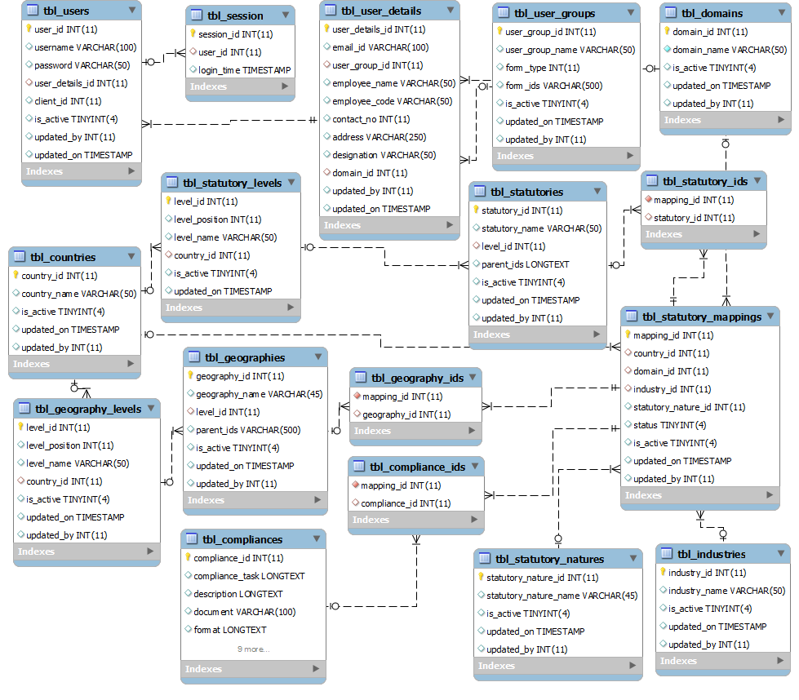

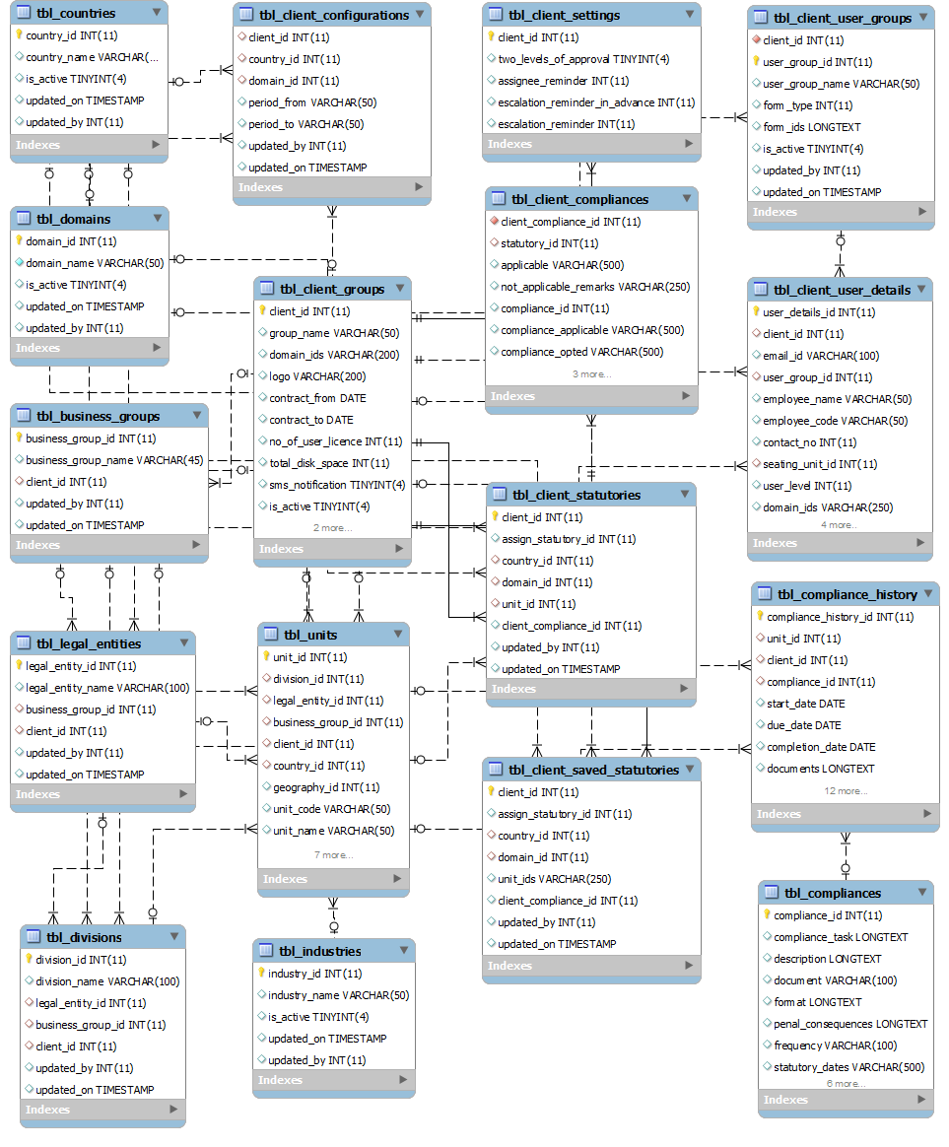

Note: These documents are strictly for Mindssoft Technology with the specific client Aparajitha Corporate Services Private Limited use only. They shall not be shared with an external party other than the client concerned. These documents should always be kept securely from unauthorized use or disclosure to a third party.

Document Approval

Mindssoft Technology and Aparajitha have reviewed this document and agree that the contents of the document are accurate. Any changes to this document must be communicated in writing, approved and signed off by both parties.

Signature | Signature
Date: | Date:
Name: N.R. Venkatesh Ram Mohan | Name:
Designation: Project Director | Designation:
Supplier: Mindssoft Technology | Client : Aparajitha

